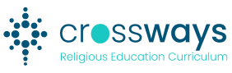
Year Level: | Title: | Term and Weeks:
Big Idea:

Stage 1 - Desired Learning and Growth

Crossways Content - Wisdom skills and dispositions, Enduring Understandings (and elaborations) and Scripture (STSS)
(exported from the Crossways website)

Learning goals/intentions: reflecting on the above, identify:
- Surface learning (knowledge acquisition)?
- Deep learning (meaning making)?
- Transfer learning?
Hopes for student faith formation (see CESA Key Capabilities Continua)

Stage 2 - Evidence of Learning (Assessment)  What evidence will be collected that aligns with the identified desired learning? |  |  | Connections with stage 1
Stage 3 - Learning Opportunities and Strategies  What teaching and learning strategies will enable the desired learning and growth  and gathering of evidence? |  |  | Resources
Reflecting on the Teaching and Learning Design - Evaluation

